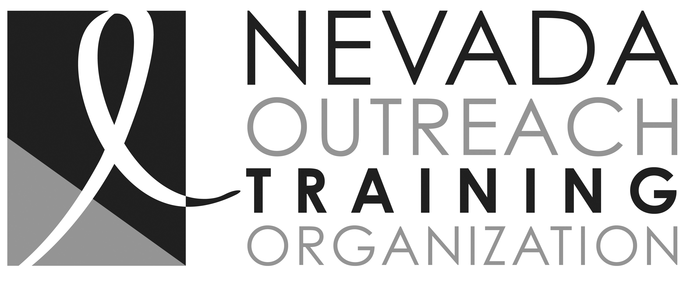

No to Abuse
Domestic Violence / Sexual Assault Advocate Job Description

Title: Domestic Violence / Sexual Assault Advocate

Reports to: Domestic Advocate Program Manager / Executive Director

Salary Range: $35,000 to $45,000 year / full time position
Note: This position is grant funded, year to year, and, as such, continued employment is contingent upon funding availability.

Qualifications: High School Diploma or G. E. D. required. Bachelor of Social Work a plus.
Must complete a minimum of 40 hours of agency approved Advocacy Training within the first three months of employment. Office experience and computer literacy are required. This position requires reliable transportation. A background check is required for this position. Bilingual (Spanish) is required.

Job Duties: Under the supervision of the Domestic Advocate Program Manager
    - Advocate for clients on an “on-call” basis (hours are flexible; employee is on call.).
    - Provide crisis intervention and advocacy by accompanying the victim through the sexual assault medical examination and the investigative process.
    - Prepare and explain “Safety Plans” with all clients.
    - Provide Case Management for clients and inputting into the CMIS case management software.
    - Provide information regarding Victim Crime Compensation Program administered though the Attorney General's Office.
    - Provide referrals to community resources, including mental health and medical resources, as needed.
    - Provide legal advocacy by supporting the victim through the court process and ensuring timely availability of information.
    - Maintain contact with all agencies involved in the investigation so that information may be provided to the victims and family members.
    - Report suspected child abuse/elder abuse and/or neglect, as a mandated reporter.
    - Facilitate support groups and continue emotional support to victims and families.
    - Follow-up as to the appropriateness of referrals and the victim’s ability to answer questions about all available services.
    - Attend at all staff meetings and staff trainings.
    - Other duties as assigned by the Program Manager.

___________________________________ _____________________
Employee Signature Date

